**Gaming equipment rental price calculation API**

Basic Authentication to handle endpoint

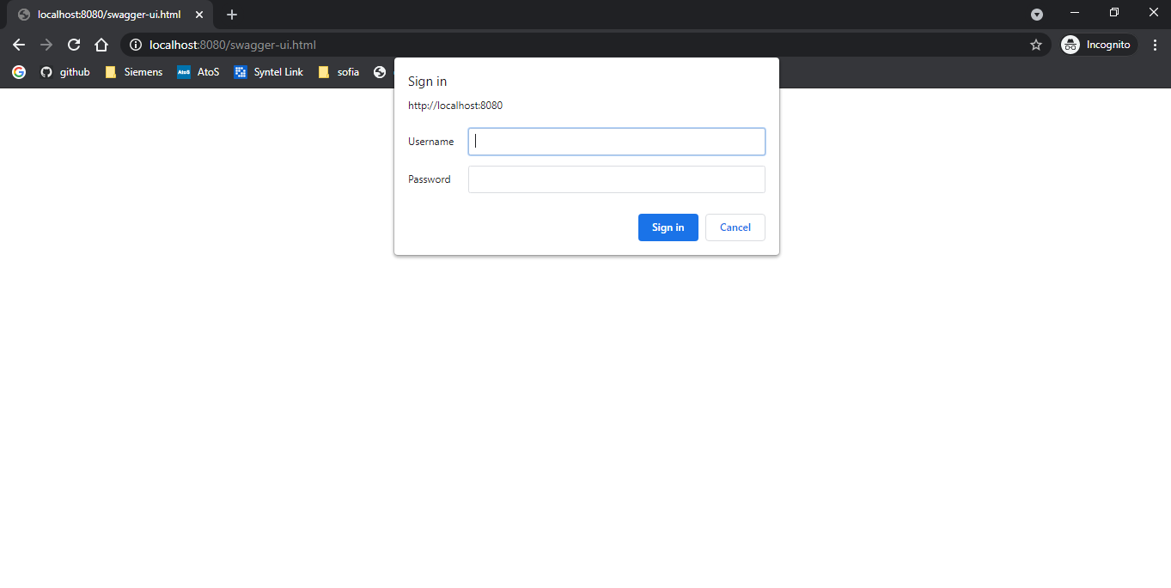

After authentication:

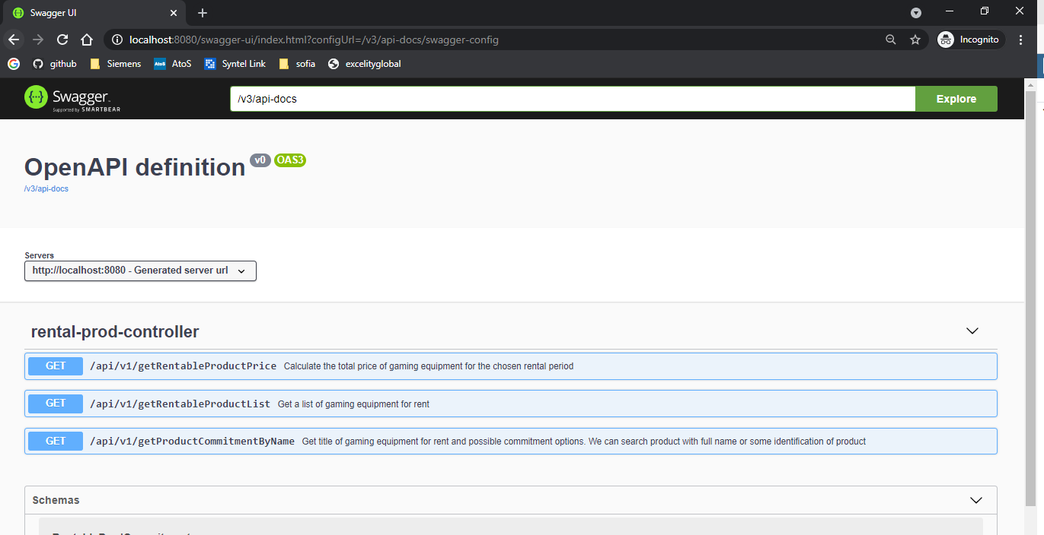

Gaming equipment rental price calculation API

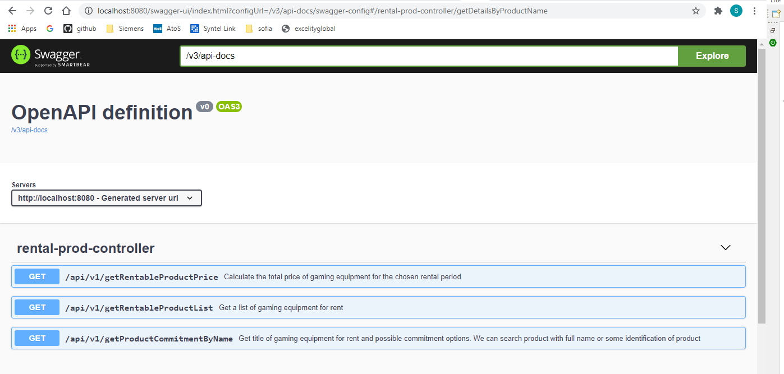

1. **API users can get a list of gaming equipment for rent.**

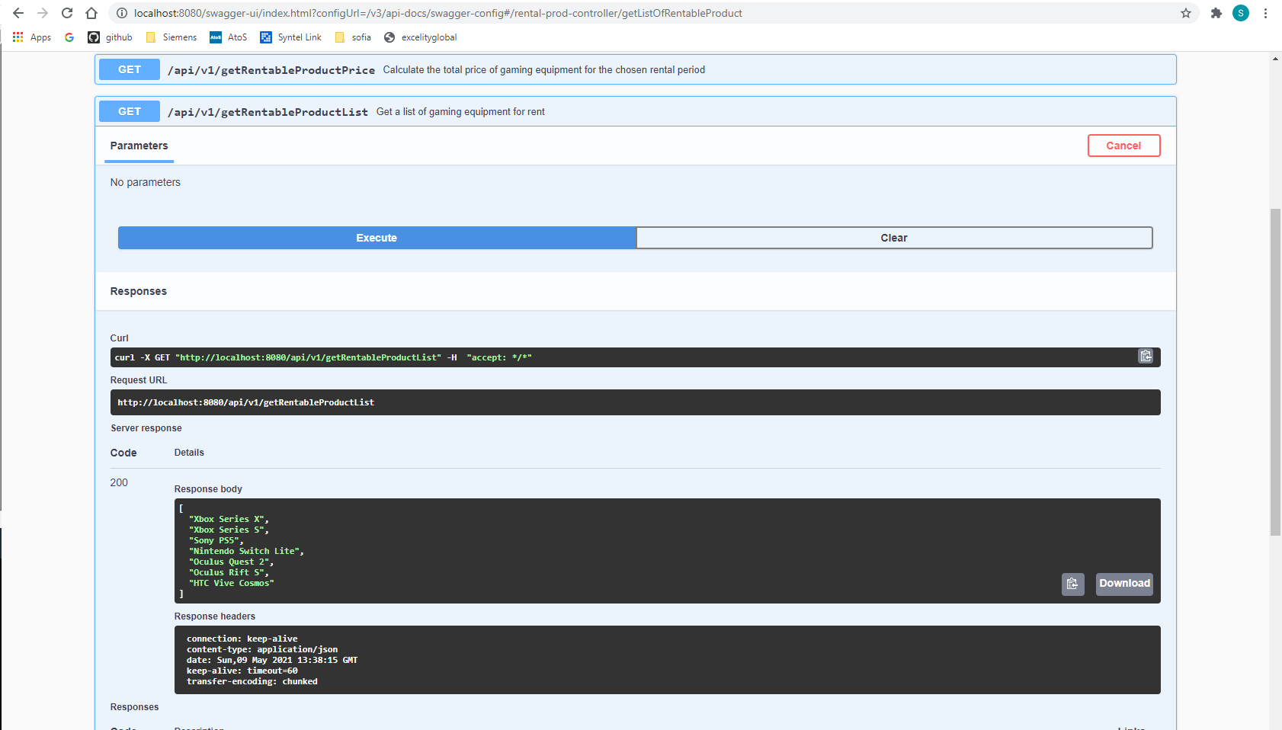

1. **API users can choose a single product and get it's title and possible commitment options**

Search by product Name

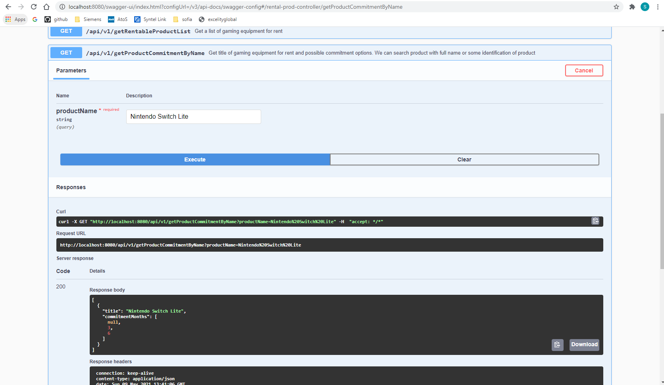

Search By identification letter

For exmaple : series

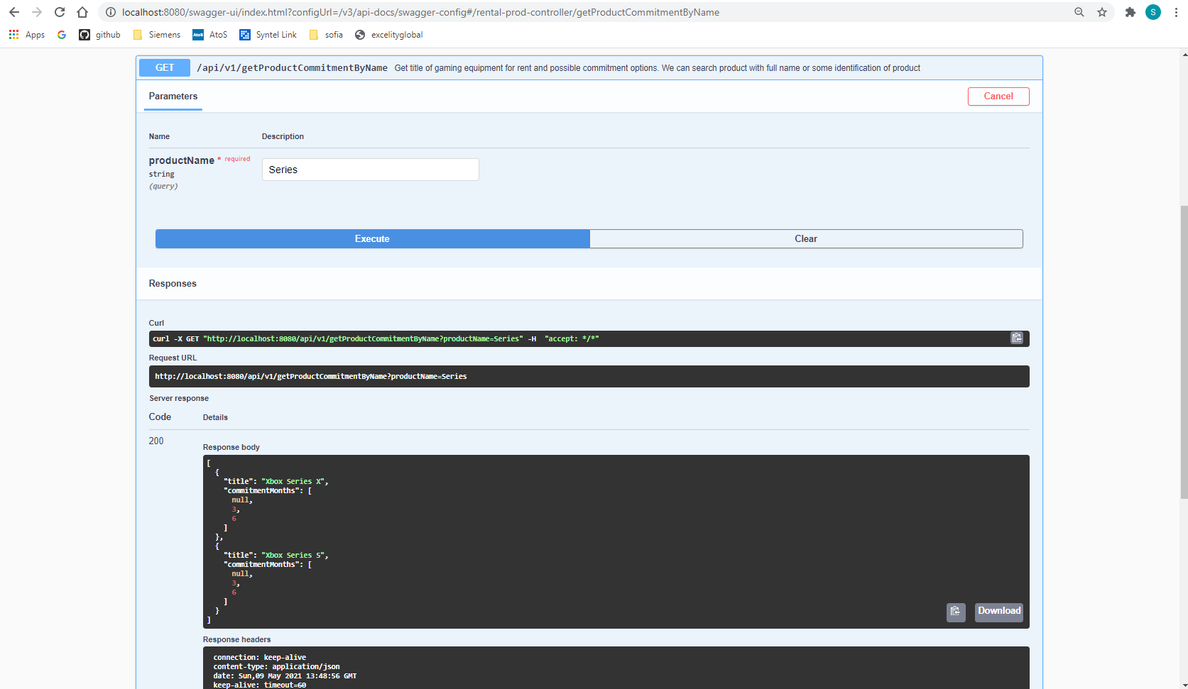

1. API users can calculate the total price for the chosen rental period, if they provide:

* the chosen product

* the chosen commitment time (number)

* optionally, the number of months after which they will return the equipment

**How I calculated initial charge**

Inside database table Initial charge column not mentioned in any table.

Below way I calculated initial charge of gaming equipment.

1. Find Id of product Name.

For ex: Xbox Series X product id is 1.

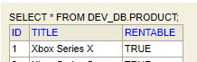

1. Find assigned price id of prodcut in prodcut_price table.

For ex. Product_id 1 assigned price_id (1,6,11)

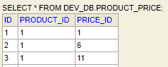

1. Find price(value) of commitment_months is equal to null. i.e initial charge of product(gaming equipment)

For exmaple. Price_id of 1,6,11 highlighted with blue color and commitment_months highlighted with red colors and their value is 35. So Initial charge of Xbox Series X equipment is 35 EUR.

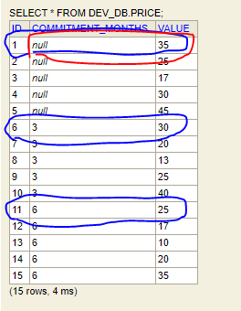

**TestCase1** User chooses an Oculus Quest 2, a commitment of 6 months, and wants to see the price they would pay if they returned the equipment after 2 months:

*price = (initial charge) 35 + (what they would pay without commitment)(2 * 35) = 105 EUR

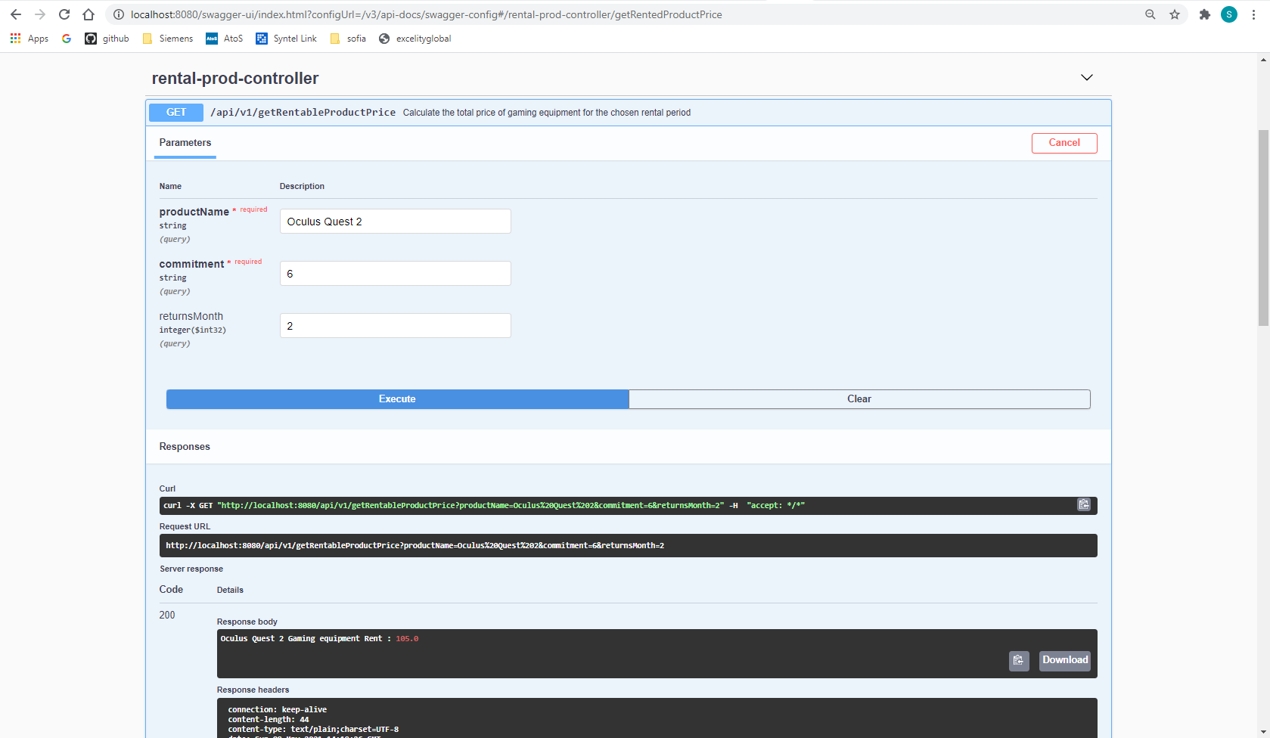

**Test Case2 :** User chooses a Nintendo Switch, no commitment, and wants to see the price they would pay if they returned the equipment after 7 months:

* price = (initial charge) 17 + (what they would pay without commitment)(7 * 17) = 136 EUR

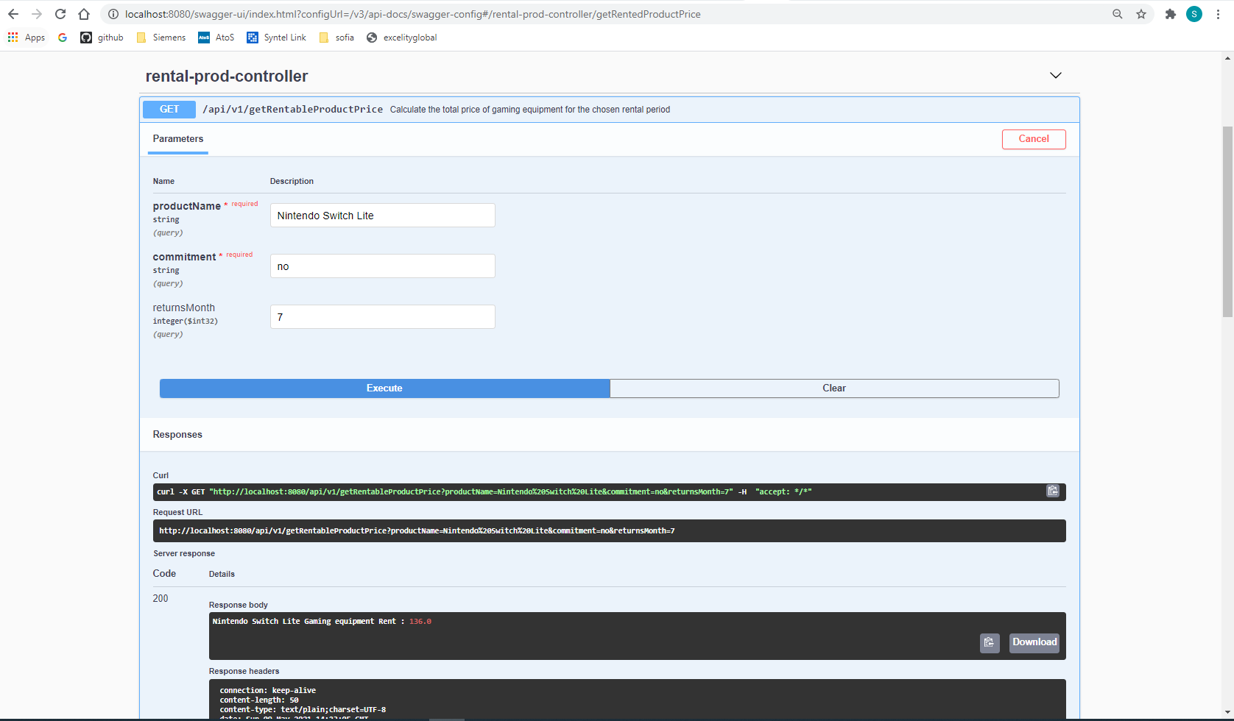

**Test case 3 :**

**Product Name Oculus Quest not avaiable for rent**

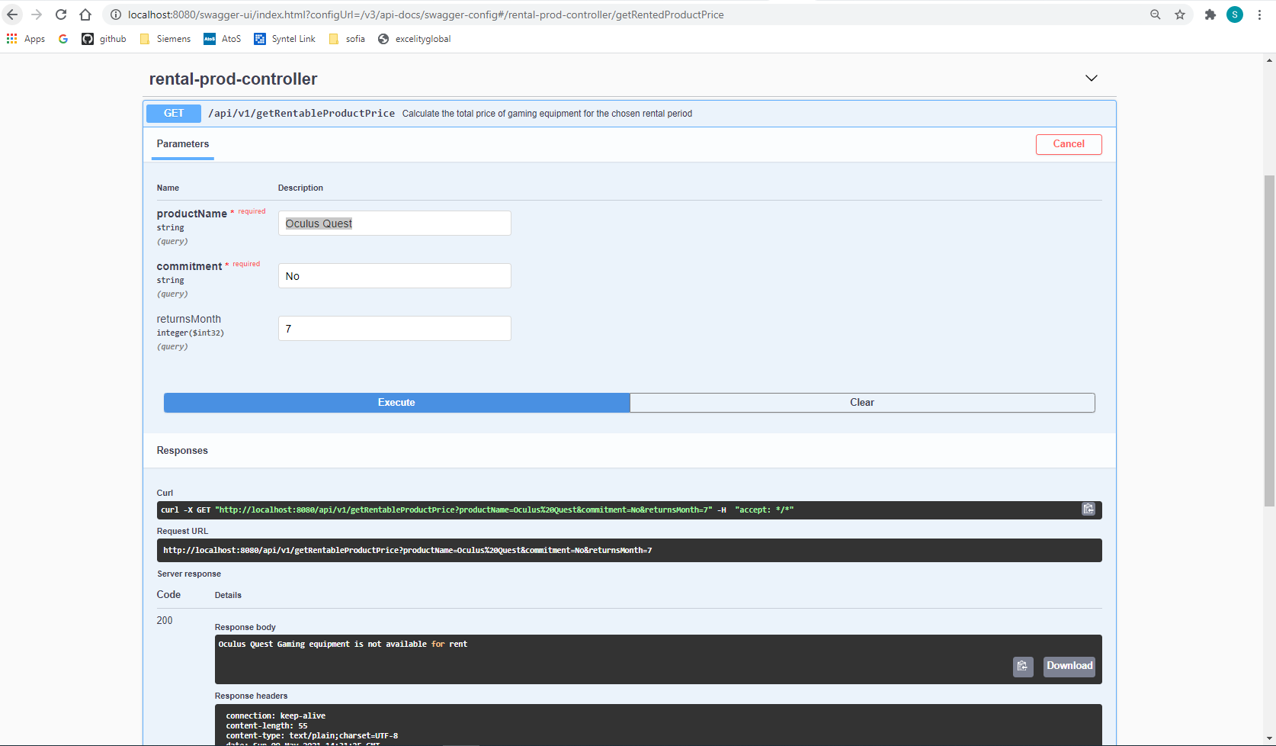

**DataBase scrrenshot**

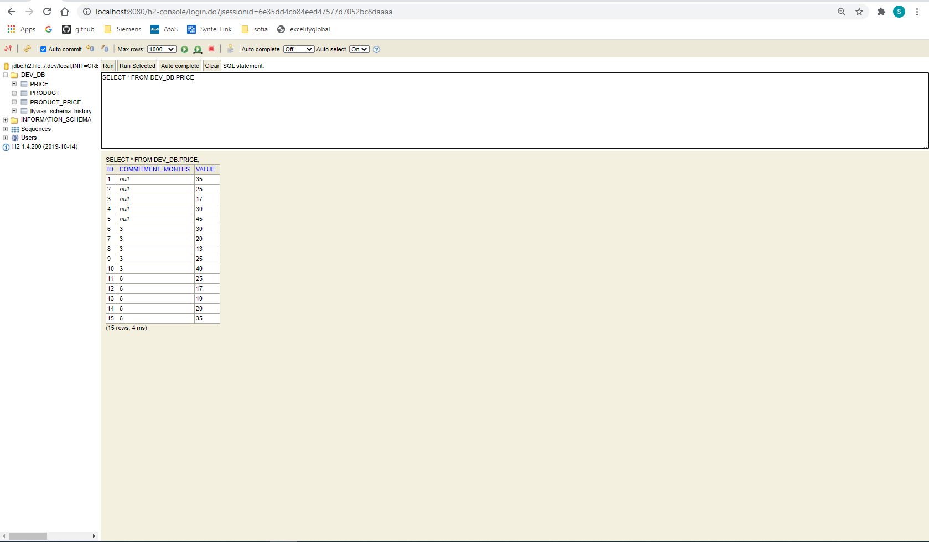

**Prapered and run docker image of service**

**Run docker image on EC2 machine**

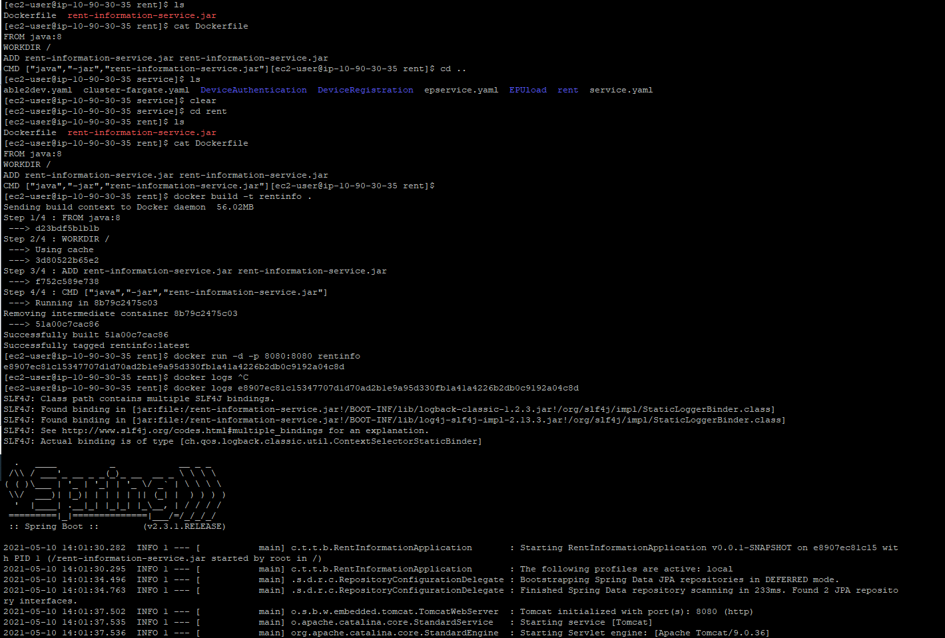

**Access service from my local browser (sucessfully run docker image)**

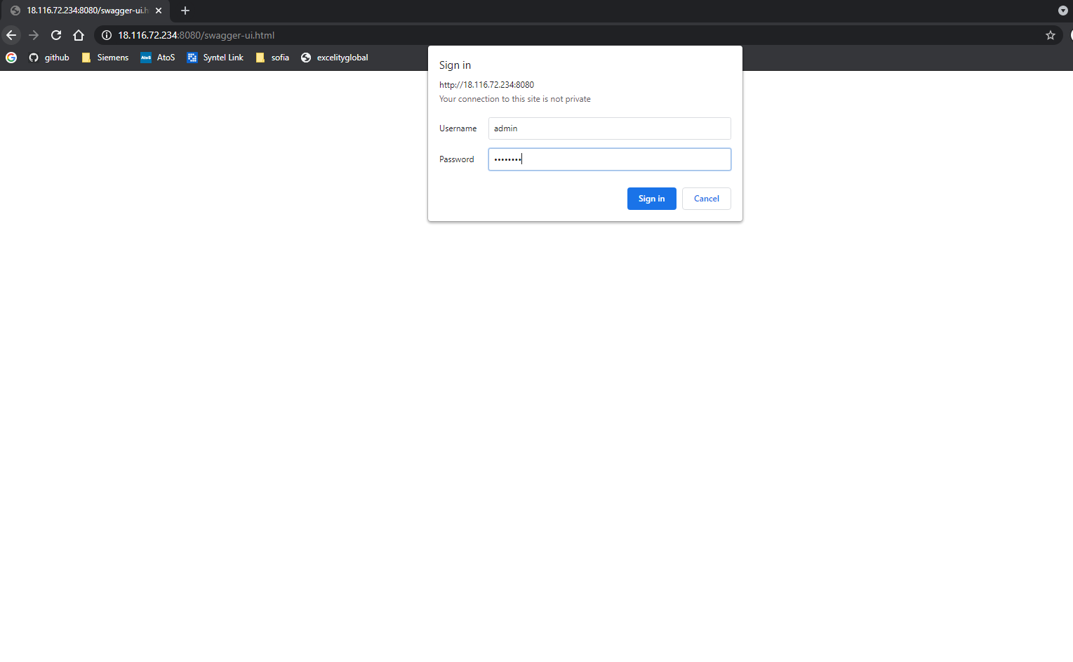

**API access once I run docker image.**

